**DAY 1 Assignment**

**DATA worker**

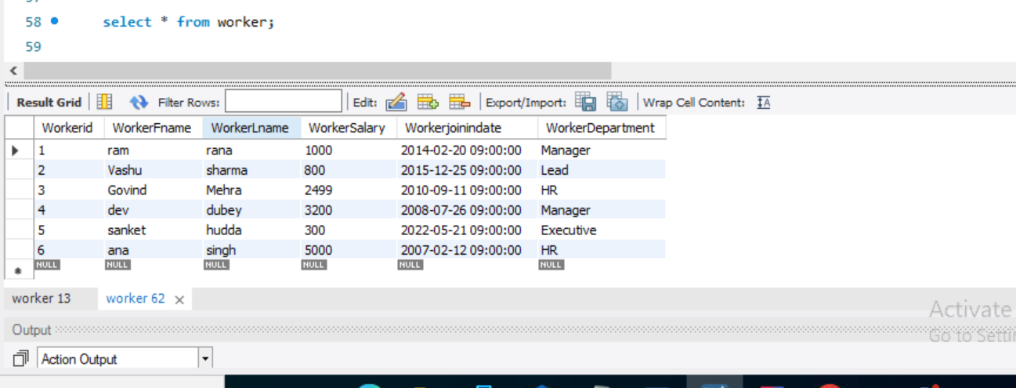

**Data title**

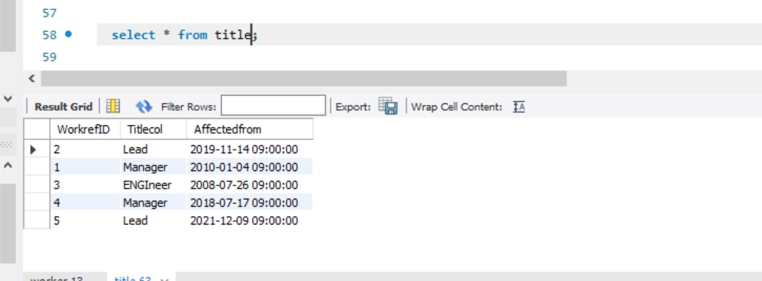

**Data bonus**

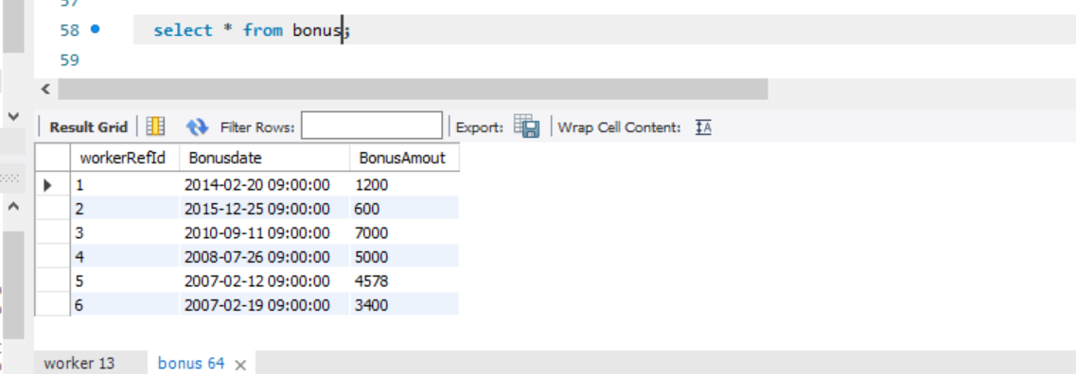

|  |  |  |  |  |  |  |  |  |
| --- | --- | --- | --- | --- | --- | --- | --- | --- |
| **Q-1. Write an SQL query to fetch “FIRST_NAME” from Worker table using the alias name as <WORKER_NAME>.** |  |  |  |  |  |  |  |  |

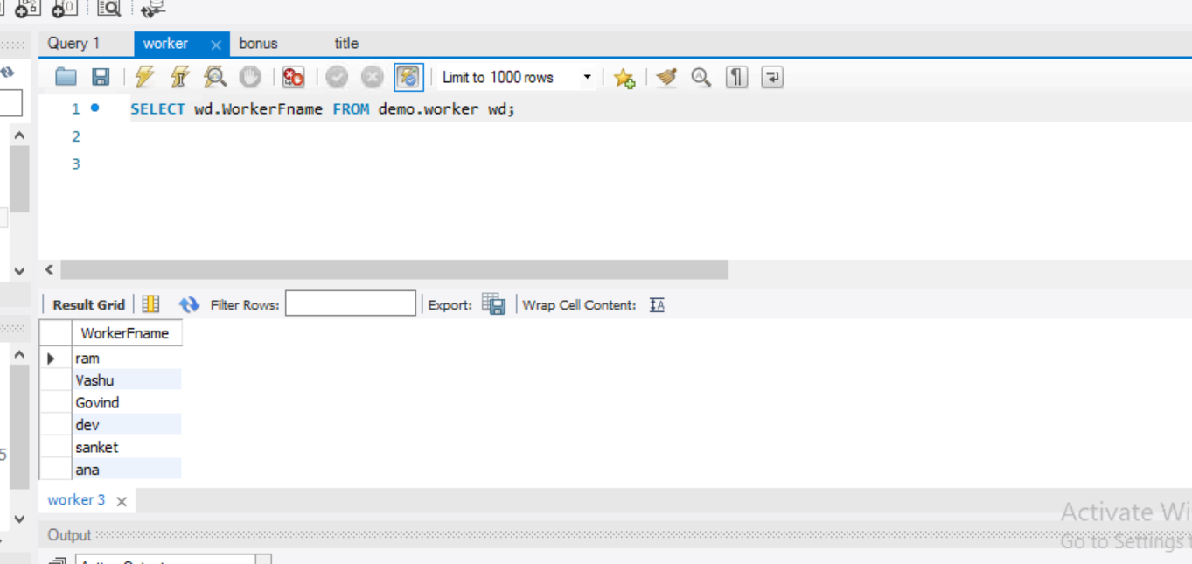

|  |  |  |  |  |  |  |  |  |  |  |  |  |  |  |  |  |  |  |  |  |  |  |  |  |  |
| --- | --- | --- | --- | --- | --- | --- | --- | --- | --- | --- | --- | --- | --- | --- | --- | --- | --- | --- | --- | --- | --- | --- | --- | --- | --- |
| **Q-2. Write an SQL query to fetch “FIRST_NAME” from Worker table in upper case.** |  |  |  |  |  |  |  |  |  |  |  |  |  |  |  |  |  |  |  |  |  |  |  |  |  |

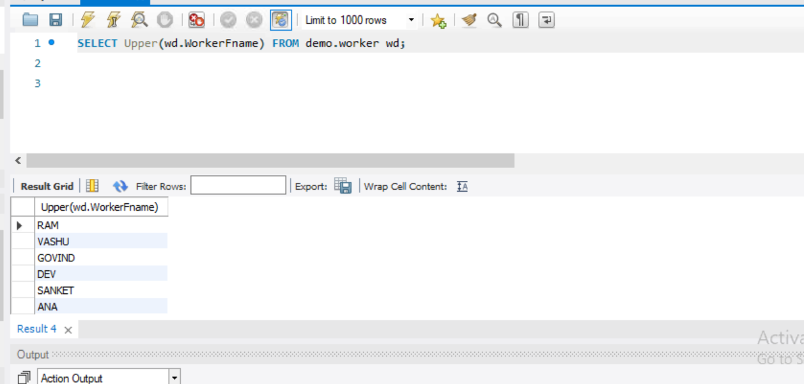

|  |  |  |  |  |  |  |  |  |  |  |  |  |  |  |  |  |  |  |  |  |  |  |  |  |  |
| --- | --- | --- | --- | --- | --- | --- | --- | --- | --- | --- | --- | --- | --- | --- | --- | --- | --- | --- | --- | --- | --- | --- | --- | --- | --- |
| **Q-3. Write an SQL query to fetch unique values of DEPARTMENT from Worker table.** |  |  |  |  |  |  |  |  |  |  |  |  |  |  |  |  |  |  |  |  |  |  |  |  |  |

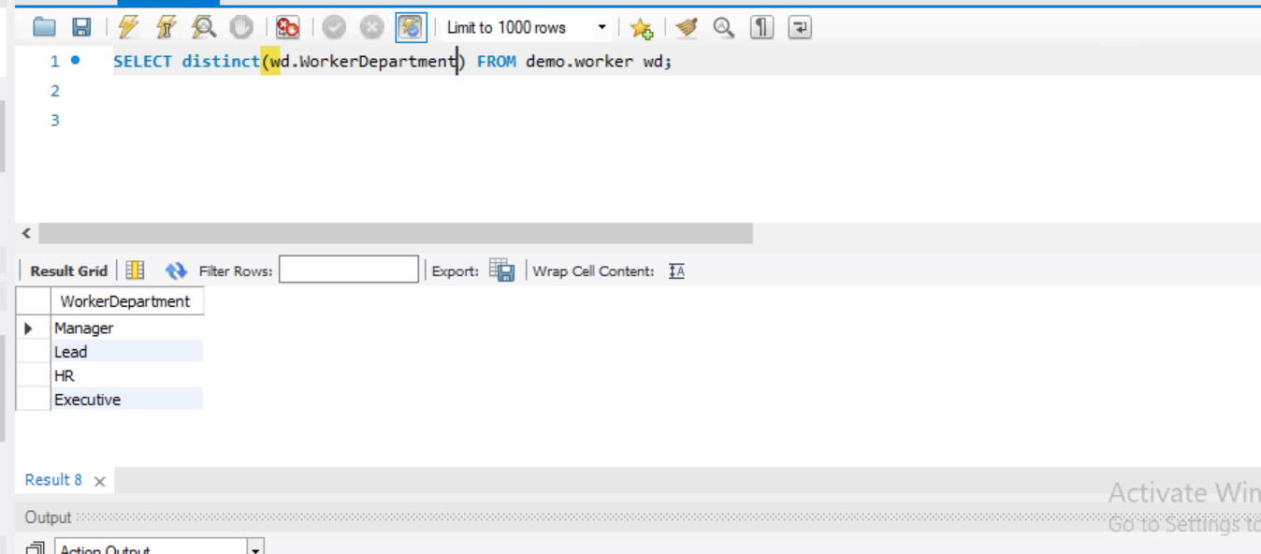

|  |  |  |  |  |  |  |  |  |  |  |  |  |  |  |  |  |  |  |  |  |  |  |  |  |  |
| --- | --- | --- | --- | --- | --- | --- | --- | --- | --- | --- | --- | --- | --- | --- | --- | --- | --- | --- | --- | --- | --- | --- | --- | --- | --- |
| **Q-4. Write an SQL query to print the first three characters of FIRST_NAME from Worker table.** |  |  |  |  |  |  |  |  |  |  |  |  |  |  |  |  |  |  |  |  |  |  |  |  |  |

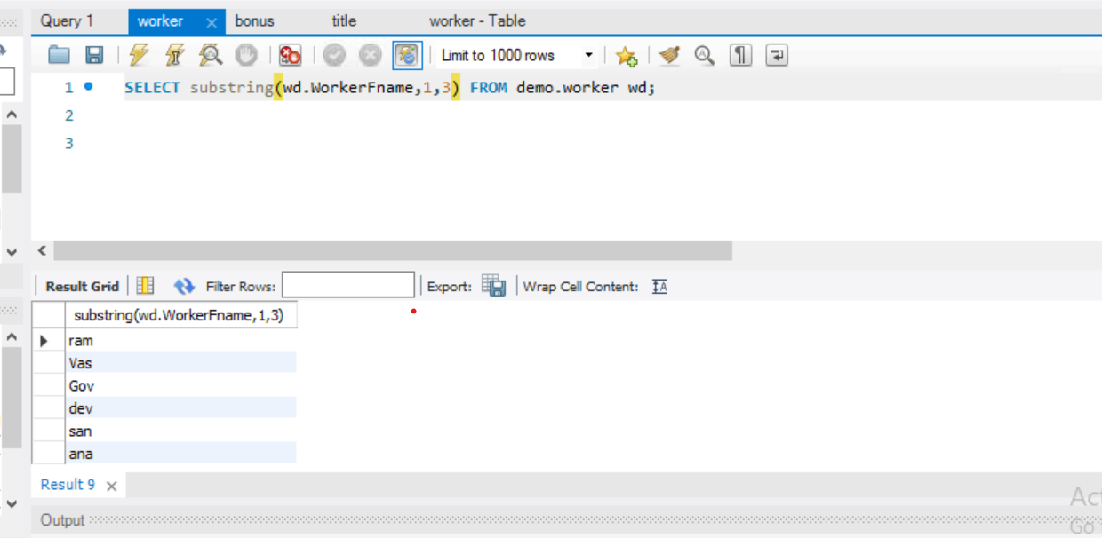

|  |  |  |  |  |  |  |  |  |  |  |  |  |  |  |  |  |  |  |  |  |  |  |  |  |  |
| --- | --- | --- | --- | --- | --- | --- | --- | --- | --- | --- | --- | --- | --- | --- | --- | --- | --- | --- | --- | --- | --- | --- | --- | --- | --- |
| **Q-5. Write an SQL query to find the position of the alphabet (‘a’) in the first name column ‘Amitabh’ from Worker table.** |  |  |  |  |  |  |  |  |  |  |  |  |  |  |  |  |  |  |  |  |  |  |  |  |  |

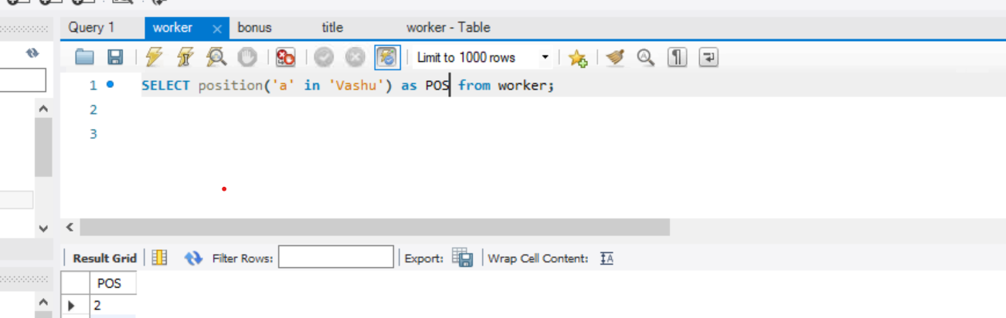

|  |  |  |  |  |  |  |  |  |  |  |  |  |  |  |  |  |  |  |  |  |  |  |  |  |  |
| --- | --- | --- | --- | --- | --- | --- | --- | --- | --- | --- | --- | --- | --- | --- | --- | --- | --- | --- | --- | --- | --- | --- | --- | --- | --- |
| **Q-6. Write an SQL query to print the FIRST_NAME from Worker table after removing white spaces from the right side.** |  |  |  |  |  |  |  |  |  |  |  |  |  |  |  |  |  |  |  |  |  |  |  |  |  |

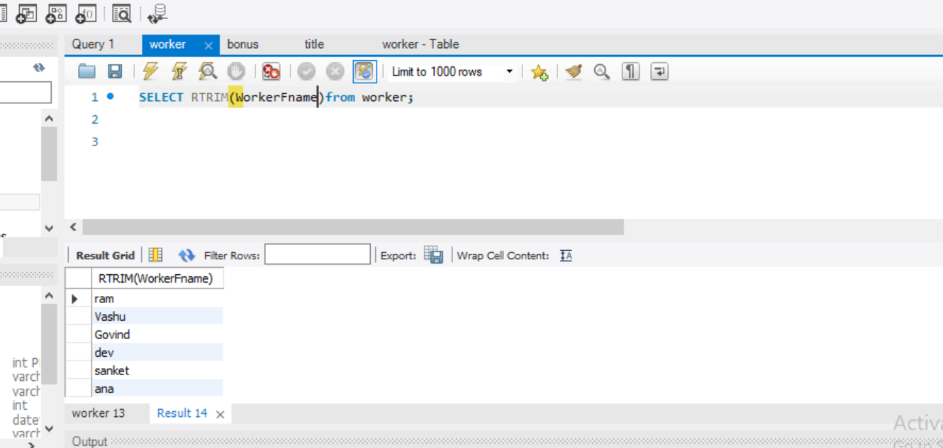

|  |  |  |  |  |  |  |  |  |  |  |  |  |  |  |  |  |  |  |  |  |  |  |  |  |  |
| --- | --- | --- | --- | --- | --- | --- | --- | --- | --- | --- | --- | --- | --- | --- | --- | --- | --- | --- | --- | --- | --- | --- | --- | --- | --- |
| **Q-7. Write an SQL query to print the DEPARTMENT from Worker table after removing white spaces from the left side.** |  |  |  |  |  |  |  |  |  |  |  |  |  |  |  |  |  |  |  |  |  |  |  |  |  |

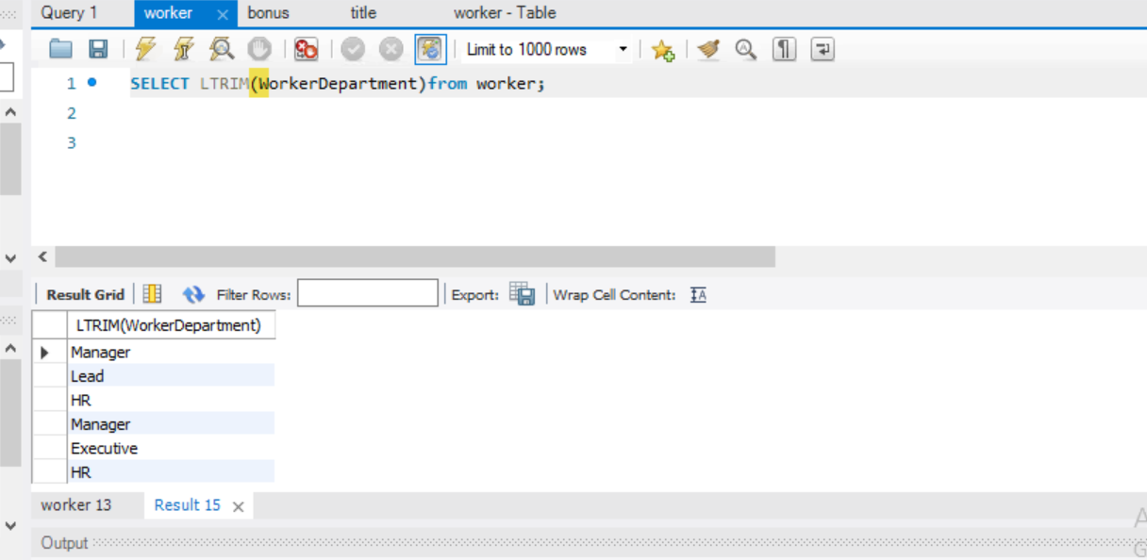

|  |  |  |  |  |  |  |  |  |  |  |  |  |  |  |  |  |  |  |  |  |  |  |  |  |  |
| --- | --- | --- | --- | --- | --- | --- | --- | --- | --- | --- | --- | --- | --- | --- | --- | --- | --- | --- | --- | --- | --- | --- | --- | --- | --- |
| **Q-8. Write an SQL query that fetches the unique values of DEPARTMENT from Worker table and prints its length.** |  |  |  |  |  |  |  |  |  |  |  |  |  |  |  |  |  |  |  |  |  |  |  |  |  |

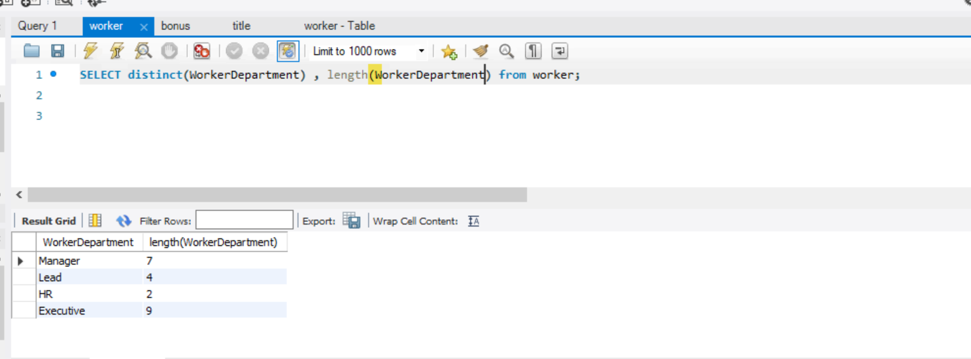

|  |  |  |  |  |  |  |  |  |  |  |  |  |  |  |  |  |  |  |  |  |  |  |  |  |  |
| --- | --- | --- | --- | --- | --- | --- | --- | --- | --- | --- | --- | --- | --- | --- | --- | --- | --- | --- | --- | --- | --- | --- | --- | --- | --- |
| **Q-9. Write an SQL query to print the FIRST_NAME from Worker table after replacing ‘a’ with ‘A’.** |  |  |  |  |  |  |  |  |  |  |  |  |  |  |  |  |  |  |  |  |  |  |  |  |  |

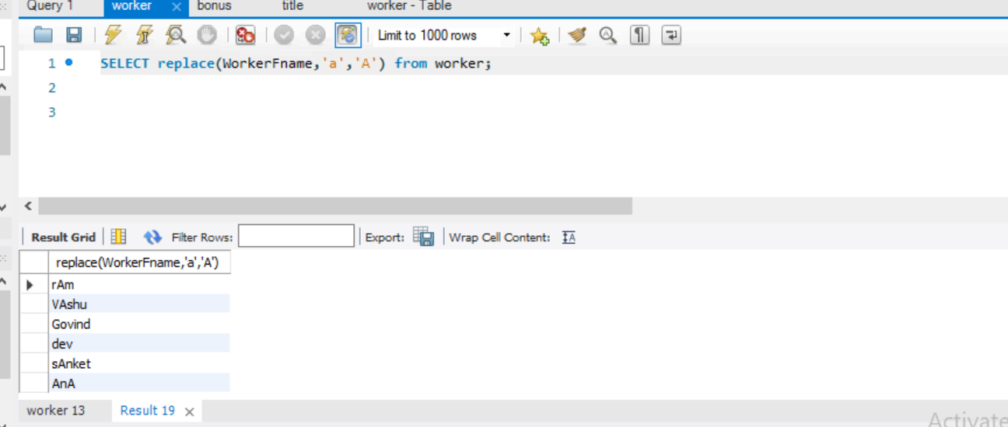

|  |  |  |  |  |  |  |  |  |  |  |  |  |  |  |  |  |  |  |  |  |  |  |  |  |  |
| --- | --- | --- | --- | --- | --- | --- | --- | --- | --- | --- | --- | --- | --- | --- | --- | --- | --- | --- | --- | --- | --- | --- | --- | --- | --- |
| **Q-10.Write an SQL query to print the FIRST_NAME and LAST_NAME from Worker table into a single column COMPLETE_NAME. A space char should separate them.** |  |  |  |  |  |  |  |  |  |  |  |  |  |  |  |  |  |  |  |  |  |  |  |  |  |

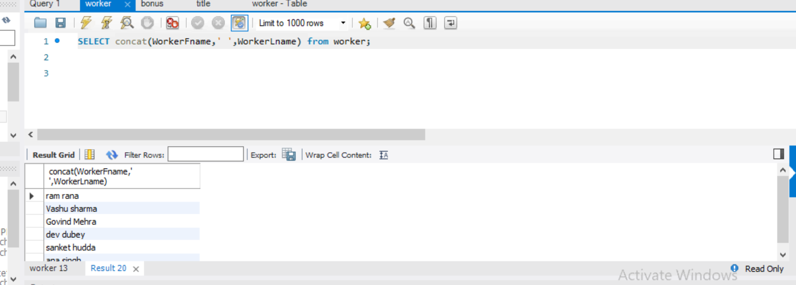

**Q-11. Write an SQL query to print all Worker details from the Worker table order by FIRST_NAME Ascending.**

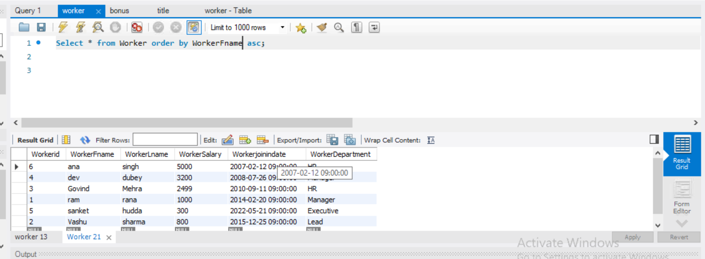

#### Q-12. Write an SQL query to print all Worker details from the Worker table order by FIRST_NAME Ascending and DEPARTMENT Descending.

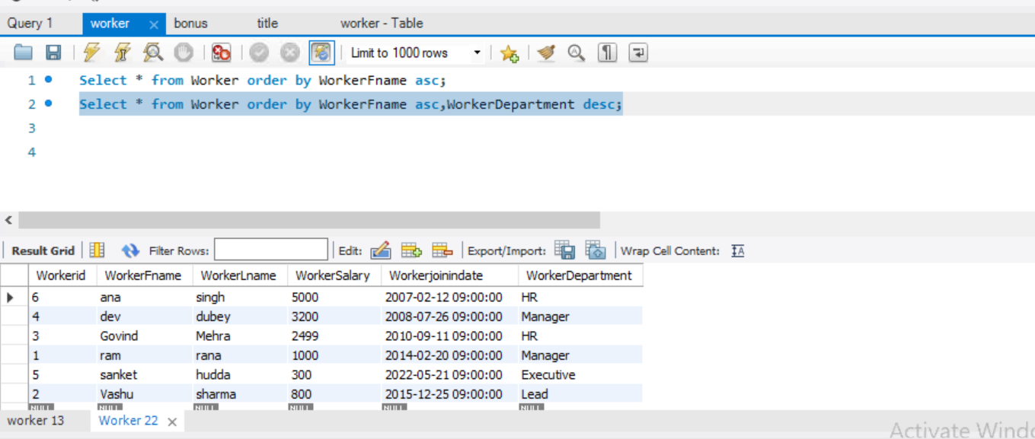

#### Q-13. Write an SQL query to print details for Workers with the first name as “ANA” and “DEV” from Worker table.

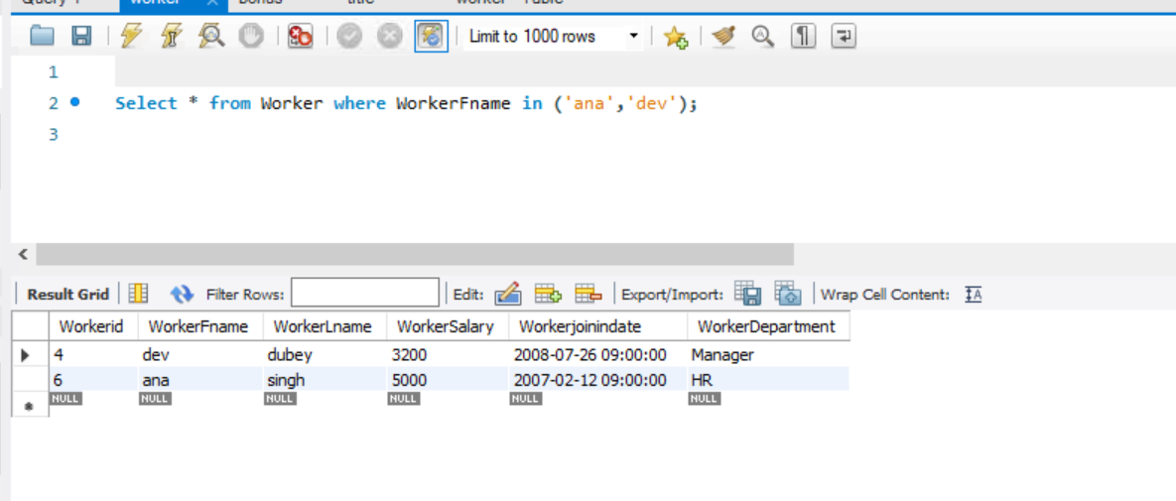

#### Q-14. Write an SQL query to print details of workers excluding first names, “ANA” and “DEV” from Worker table.

#### 

#### . Write an SQL query to print details of Workers with DEPARTMENT name as “HR”.

#### 

#### Q-16. Write an SQL query to print details of the Workers whose FIRST_NAME contains ‘a’.

#### 

#### Write an SQL query to print details of the Workers whose FIRST_NAME ends with ‘a’.

#### 

#### Q-18. Write an SQL query to print details of the Workers whose FIRST_NAME ends with ‘u’ and contains six 5.

#### 

#### Q-19. Write an SQL query to print details of the Workers whose SALARY lies between 800 and 3200

#### 

#### Write an SQL query to print details of the Workers who have joined in Feb’2014.

#### 

#### Q-21. Write an SQL query to fetch the count of employees working in the department ‘HR.

#### 

Write an SQL query to fetch worker names with salaries >= 1000 and <= 4000.

#### Write an SQL query to fetch the no. of workers for each department in the descending order.

#### 

#### Write an SQL query to print details of the Workers who are also Managers.

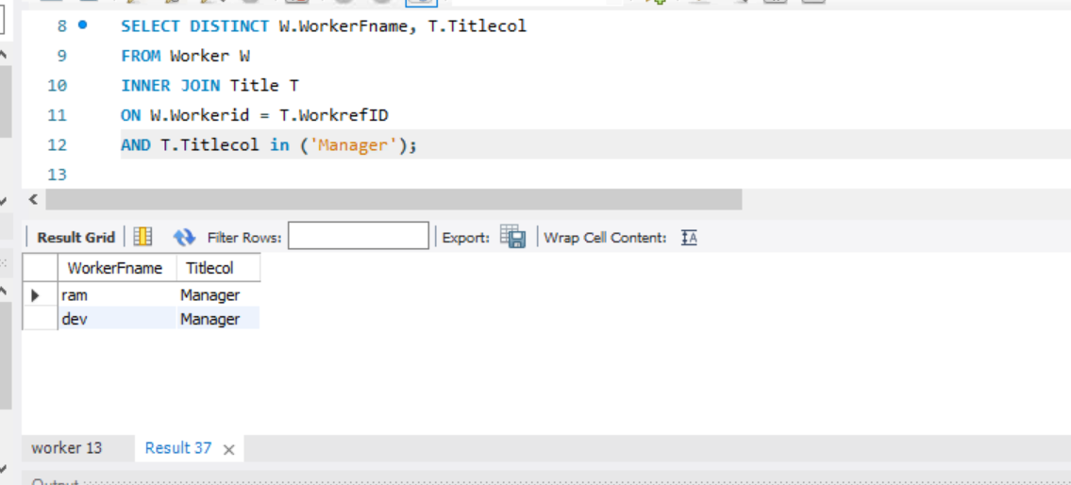

#### Q-25. Write an SQL query to fetch duplicate records having matching data in some fields of a table.

#### 

#### . Write an SQL query to show only odd rows from a table.

#### 

#### Write an SQL query to show only even rows from a table.

#### 

#### Q-28. Write an SQL query to clone a new table from another table.

#### 

#### Q-29. Write an SQL query to fetch intersecting records of two tables.

#### Q-30. Write an SQL query to show records from one table that another table does not have.

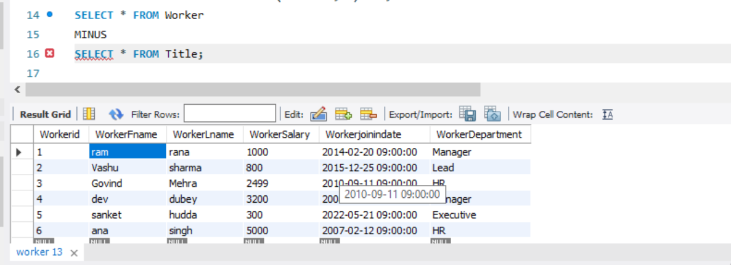

#### Write an SQL query to show the current date and time.

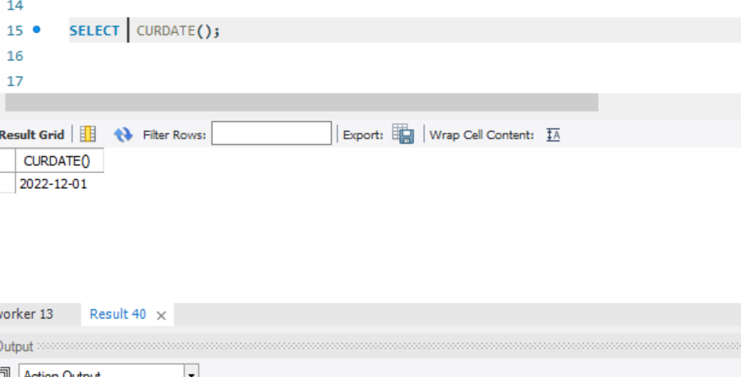

#### . Write an SQL query to show the top n (say 10) records of a table.

#### 

#### Write an SQL query to determine the nth (say n=4) highest salary from a table.

#### 

#### Q-34. Write an SQL query to determine the 5th highest salary without using TOP or limit method.

#### 

#### Q-35. Write an SQL query to fetch the list of employees with the same salary.

#### 

#### Write an SQL query to show the second highest salary from a table.

#### 

#### Q-37. Write an SQL query to show one row twice in results from a table.

#### 

#### Q-39. Write an SQL query to fetch the first 50% records from a table.

#### 

#### Q-40. Write an SQL query to fetch the departments that have less than five people in it.

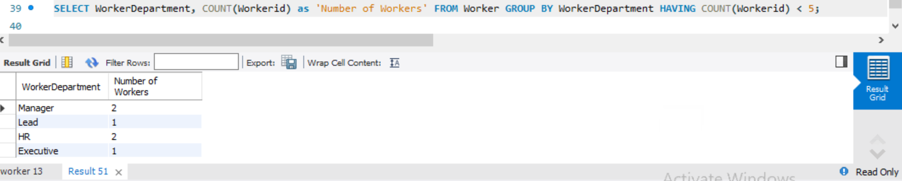

#### Write an SQL query to show the last record from a table.

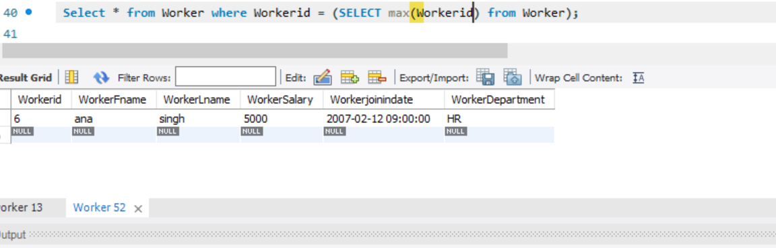

#### Write an SQL query to fetch the first row of a table.

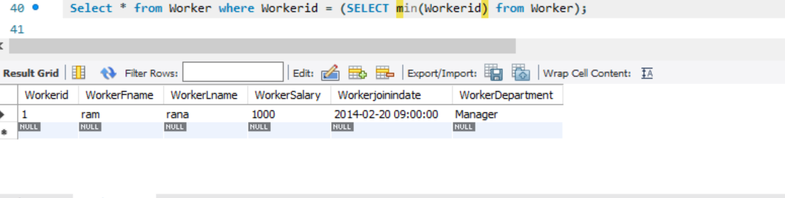

#### Write an SQL query to fetch the last five records from a table.

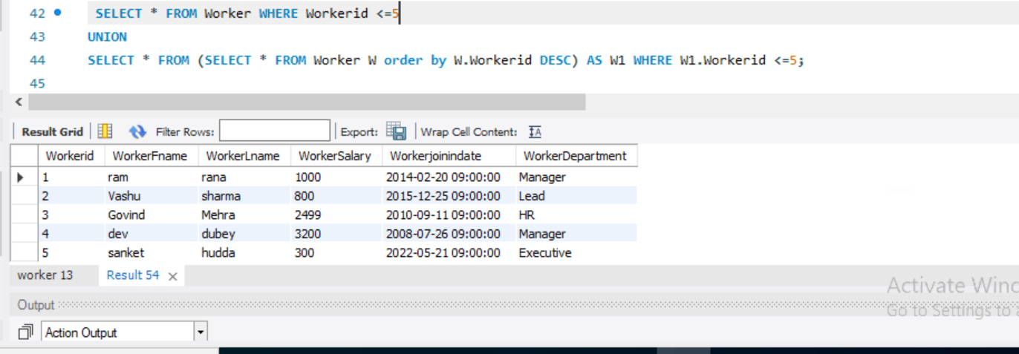

#### Q-45. Write an SQL query to print the name of employees having the highest salary in each department.

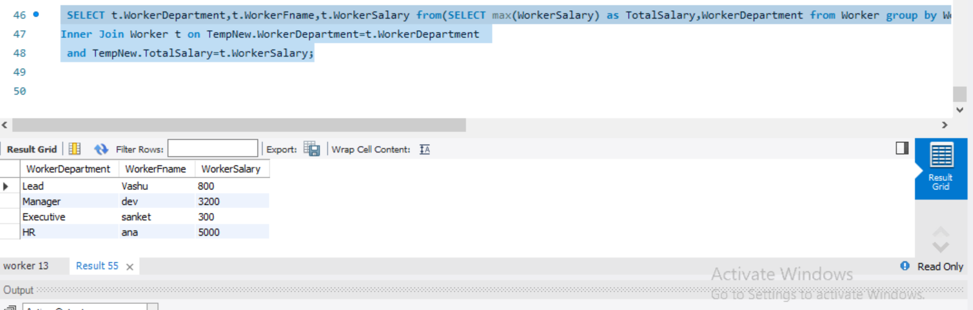

#### Write an SQL query to fetch three max salaries from a table.

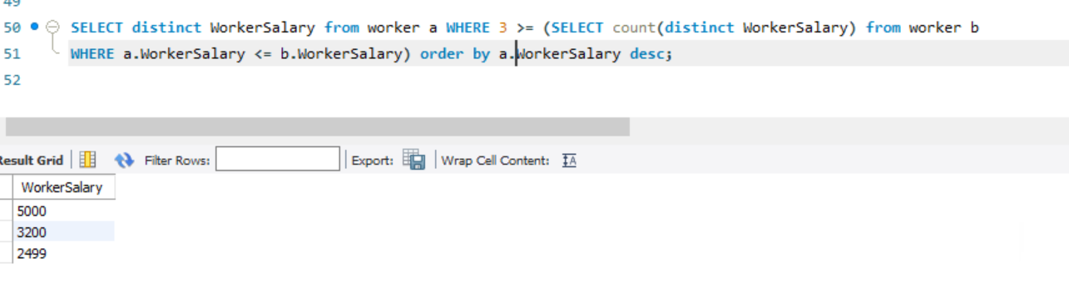

#### Q-47. Write an SQL query to fetch three min salaries from a table.

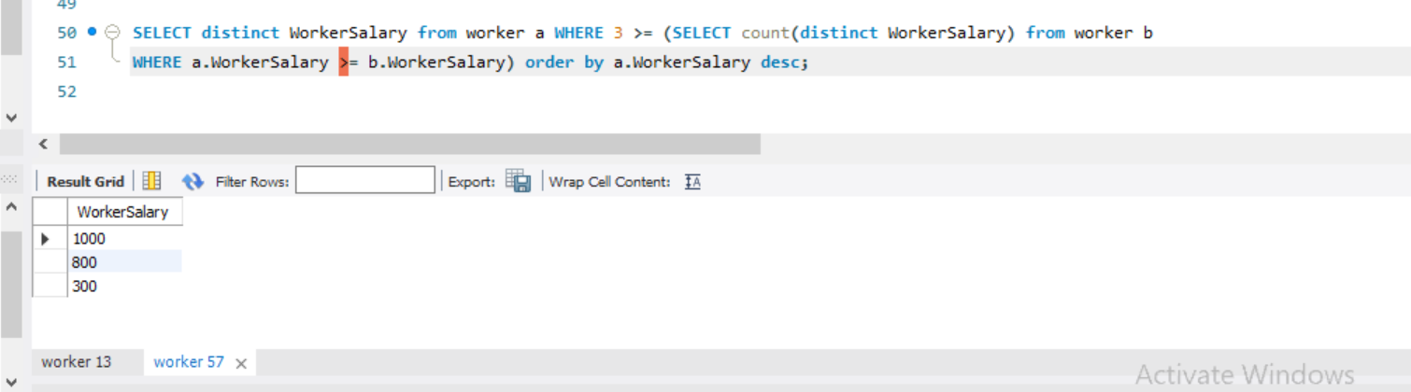

#### Q-48. Write an SQL query to fetch nth max salaries from a table.

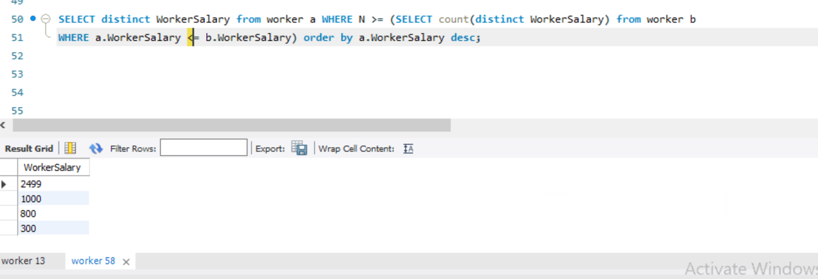

#### Q-49. Write an SQL query to fetch departments along with the total salaries paid for each of them.

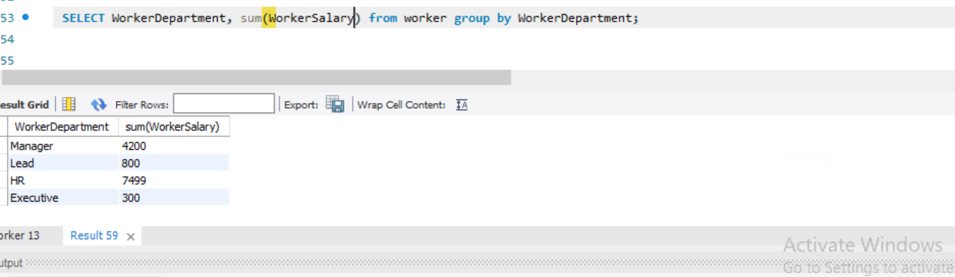

#### Q-50. Write an SQL query to fetch the names of workers who earn the highest salary.

